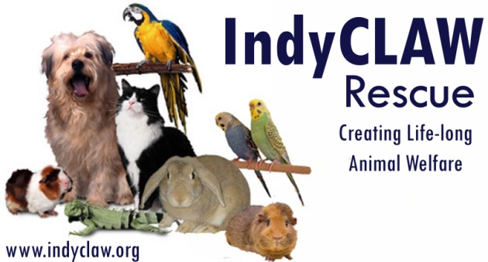
-Adoption
Questionnaire

Thank you for your interest in adopting a homeless pet! IndyCLAW is an all-volunteer, member-supported non-profit organization dedicated to improving the lives of companion animals.
The goal of our adoption program is to match pets with families to best accommodate the needs and interests of both. Please complete the following application so we can get to know you better and to begin the adoption process.
Date

Personal Information
First Name (s) | Last Name
Address
City | State | Zip Code
Phone Number (s) | Email
Best time to contact | Driver's License Number (or state ID)
How did you hear about IndyCLAW Rescue?
Are you at least 18 years old? YesNo

Adoption inquiry
Which pet do you wish to adopt? alternate:
What are your reasons for adopting this pet? (choose all that apply)
Companion for me | Classroom Pet
For the children | Other, specify:
Companion for other pets

What characteristics are you looking for in your new companion?

Please describe where your pet will spend its days, and if different, nights.

Pets require regular exercise. How much time do you think your new pet will be able to exercise over the typical week?

If you plan to give your pet outdoor exercise, how will it be supervised/protected?

Some pets have sensitive digestive systems, so their diet is very important to keeping them healthy. Please describe your pet's daily menu.
If you would like more info on proper diet, check here:
Are you willing and able to make accommodations for pet's natural tendency to chew/dig/etc?
Yes | No | Not sure

If your pet's behavior is troublesome to you how long are you willing to work towards modifying any behaviors that may develop?

Most pets can live 10 to 20 years (with some species living much longer; some tropical birds live into their 70’s). Are you committed to providing emotionally and financially for this pet for his/her entire life?
Yes | No | Not sure

Do you have a current veterinarian? If so, please indicate doctor’s name, vet office name and address & phone number.

Do you know if your vet is experienced in the unique needs of this pet (Exotic pets need special vets)?
Yes | No | Not sure

Household Information
What type of housing do you have? Own Rent
If renting, does your lease allow pets? Yes No
Does anyone smoke inside your home (while hazardous to most pets, it can be deadly to birds)?
Yes No Comment: _____________________________________________________
Please tell us about the people in your household.
Name | Relationship to adopter | Age, if minor | Role in care of the pet | Will this be a Primary care giver?

Please describe any companion animals currently in your household.
Species | Names | Age | Primarily lives where?  (outdoors, indoors or cage) | Check here if spayed/neutered

Please list any companion animals that have lived with you in the past 5 years but do not currently.
Species | Primarily lived where? | Where are they now? | Check here if euthanized

Does anyone in the household have animal or grass/hay allergies?
YesNoNot sure
If so, describe how you plan to manage the allergies:

If you have other companion animals, how do you plan to introduce your new pet to the current residents?

Personal References
Name | Relationship | Phone number(s) | eMail

Please note that :
- The fee paid at the point of adoption is nonrefundable, however, there is not an application fee and no money is due until the adoption is complete
- After the adoption is completed, all expenses (including medical expenses) are solely the adopter's responsibility
- There will be an adoption contract requiring life-long, species specific care of your selected companion animal and includes a provision that it will return to IndyCLAW if it can no longer stay with the approved adopter.
- IndyCLAW may deny any application
To complete the questionnaire, please double check all your information, save the document and return to IndyCLAW as an email attachment or in person. If you have any questions, please do not hesitate to contact us at adopt@indyclaw.org .


Thank you for considering a rescued animal for your next companion pet!


